1. Conditions
Provide the reagents and conditions necessary to effect the following reactions.

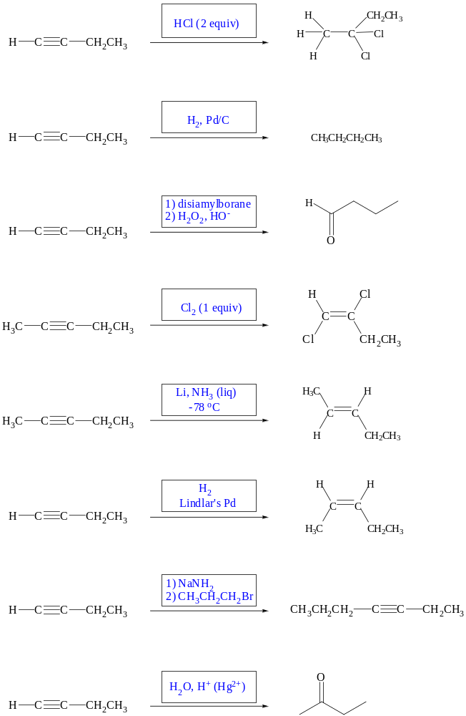

2. Products
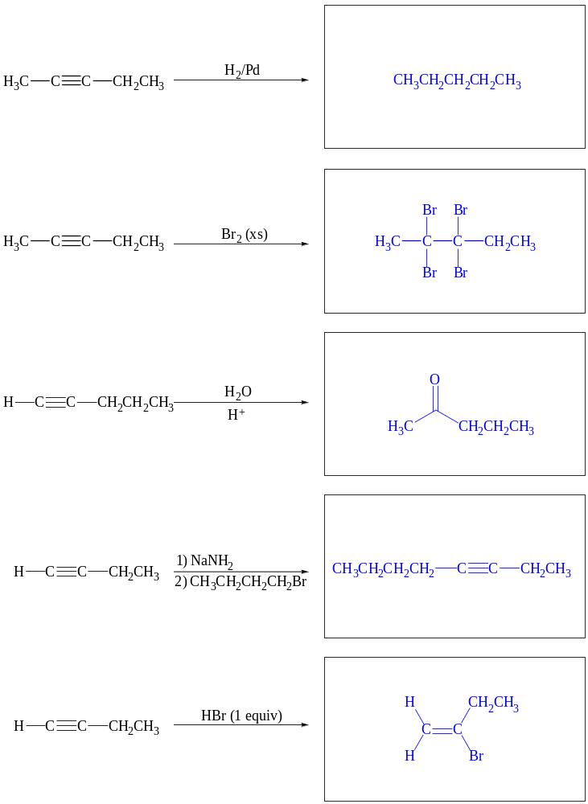Draw the major product or products of each reaction. If the reaction is stereoselective, be certain that your structure(s) clearly indicate the correct stereochemistry.

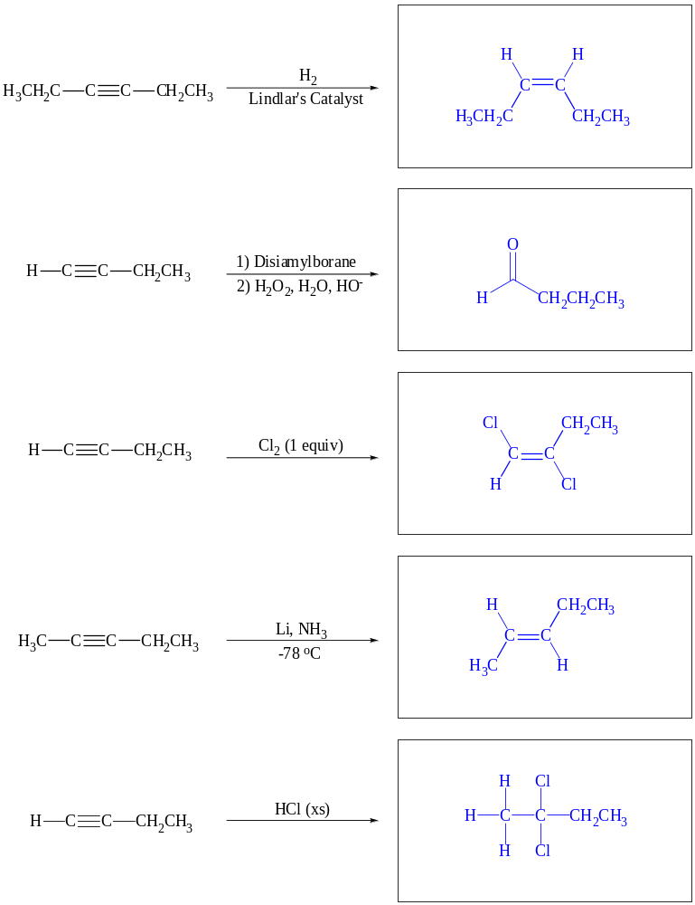

3. Reactants
Draw the reactant that would undergo the reactions shown. If the reaction is stereoselective, be
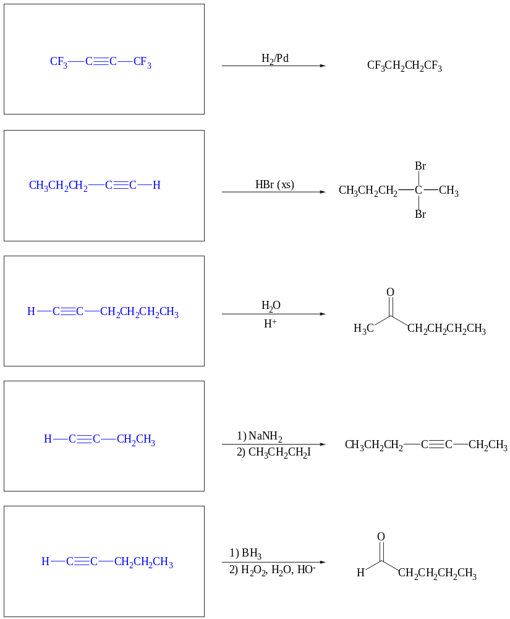

4. Mechanism
Provide a complete arrow-pushing mechanism for the following reaction.

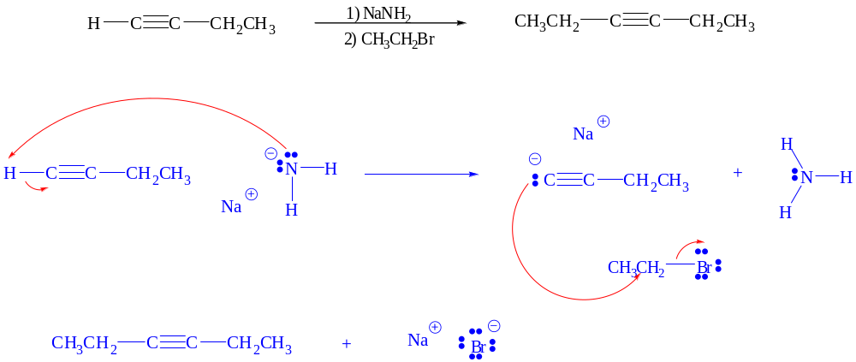

5. Synthesis
Propose a multi-step synthesis of each target molecule starting with the compound provided. Show the necessary reagents and products for each step.


